Head motion greatly distorts the blood-oxygenation level dependent (BOLD) signal that underlies both task-driven functional MRI (fMRI) activations and resting-state functional connectivity MRI (rs-fcMRI) [1-7]. For rs-fcMRI data it has been shown that systematic between-group differences in “micro-movements” (> 0.2 mm) significantly distort BOLD data. Unwanted head motion during MRI scanning is significantly greater in infants, children and populations with neuropsychiatric disorders.

Frame censoring or removing individual BOLD images (‘frames’) distorted by head movement can successfully correct motion-distorted fMRI data. Post-hoc frame censoring for frame-wise displacements (FD) of > 0.2 effectively corrects for movement-distortion and has become the new gold standard for rs-fcMRI studies. Depending on age and disease-status data loss rates from frame censoring can be above 50%. The recognition that frame censoring is absolutely necessary for collecting unbiased rs-fcMRI data has massively increased the cost of such research. Therefore, our site has adopted a novel approach that greatly reduces rs-fcMRI costs by using real-time head motion information to guide data collection - Framewise Integrated Real-time MRI Monitor (FIRMM).
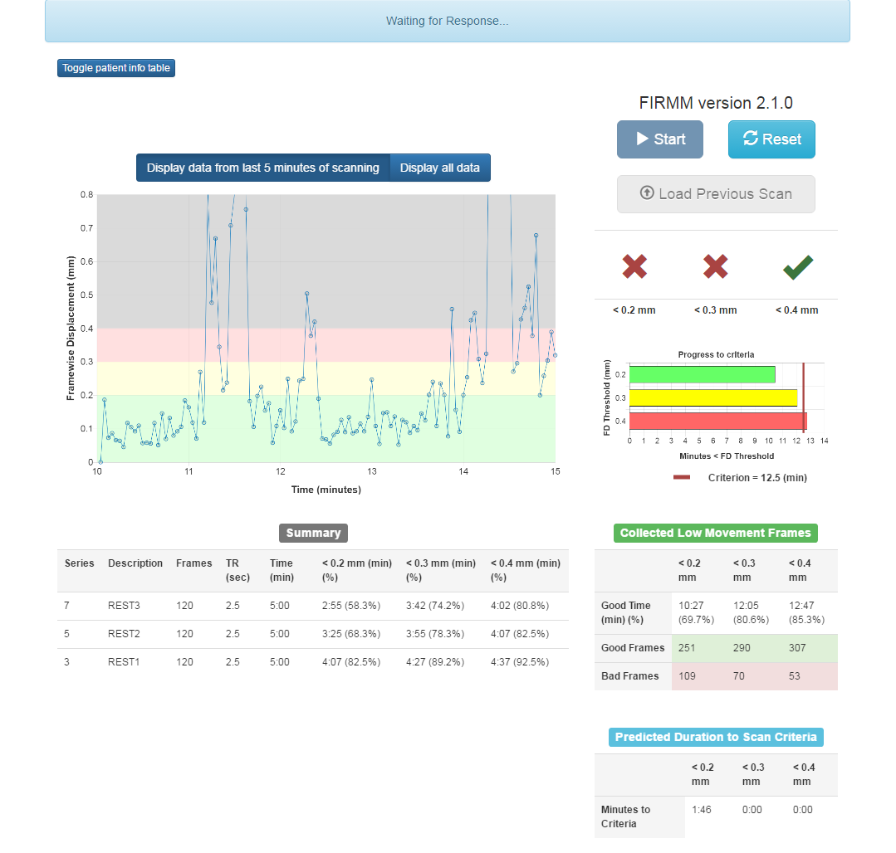
FIRMM is a new software suite that computes head motion (FD) in real-time, using frame alignment algorithms optimized for speed. FIRMM’s graphical user interface (GUI) displays real-time motion (FD) in a graph and also continuously updates summary statistics about data quality metrics, namely how many usable BOLD images (FD < 0.2) have already been collected. The GUI is easy to use and protects against operator errors (Figure 1). The implementation of real-time motion monitoring now allows us to collect rs-fcMRI in a more efficient and cost effective manner.

Pilot studies of FIRMM have demonstrated its utility for reducing scan times and associated costs (citation). For example, a new publication that has analyzed FD data from a sample of 1134 children and adolescents with and without developmental psychopathologies (i.e. ADHD and/or ASD) have been examined with FIRMM and show improved efficiency for collecting quality data.

Frame censoring, FIRMM and an adaptive head-movement driven fMRI data collection paradigm now allow us to collect the right amount of movement-free data for each subject, simultaneously boosting subject retention and lowering costs.

References
1. Power JD, Barnes KA, Snyder AZ, Schlaggar BL, Petersen SE. Spurious but systematic correlations in functional connectivity MRI networks arise from subject motion. NeuroImage. 2012;59(3):2142-54. doi: 10.1016/j.neuroimage.2011.10.018. PubMed PMID: 22019881; PubMed Central PMCID: PMC3254728.
2. Power JD, Barnes KA, Snyder AZ, Schlaggar BL, Petersen SE. Steps toward optimizing motion artifact removal in functional connectivity MRI; a reply to Carp. NeuroImage. 2012. doi: 10.1016/j.neuroimage.2012.03.017. PubMed PMID: 22440651.
3. Power JD, Mitra A, Laumann TO, Snyder AZ, Schlaggar BL, Petersen SE. Methods to detect, characterize, and remove motion artifact in resting state fMRI. NeuroImage. 2013;84C:320-41. doi: 10.1016/j.neuroimage.2013.08.048. PubMed PMID: 23994314.
4. Fair DA, Nigg JT, Iyer S, Bathula D, Mills KL, Dosenbach NU, Schlaggar BL, Mennes M, Gutman D, Bangaru S, Buitelaar JK, Dickstein DP, Di Martino A, Kennedy DN, Kelly C, Luna B, Schweitzer JB, Velanova K, Wang YF, Mostofsky S, Castellanos FX, Milham MP. Distinct neural signatures detected for ADHD subtypes after controlling for micro-movements in resting state functional connectivity MRI data. Frontiers in systems neuroscience. 2012;6:80. doi: 10.3389/fnsys.2012.00080. PubMed PMID: 23382713; PubMed Central PMCID: PMC3563110.
5. Satterthwaite TD, Wolf DH, Loughead J, Ruparel K, Elliott MA, Hakonarson H, Gur RC, Gur RE. Impact of in-scanner head motion on multiple measures of functional connectivity: Relevance for studies of neurodevelopment in youth. NeuroImage. 2012;60(1):623-32. doi: 10.1016/j.neuroimage.2011.12.063.
6. Van Dijk KRA, Sabuncu MR, Buckner RL. The influence of head motion on intrinsic functional connectivity MRI. NeuroImage. 2012;59(1):431-8. doi: 10.1016/j.neuroimage.2011.07.044.
7. Smyser CD, Inder TE, Shimony JS, Hill JE, Degnan AJ, Snyder AZ, Neil JJ. Longitudinal analysis of neural network development in preterm infants. Cerebral cortex. 2010;20(12):2852-62. doi: 10.1093/cercor/bhq035. PubMed PMID: 20237243; PubMed Central PMCID: PMC2978240.

